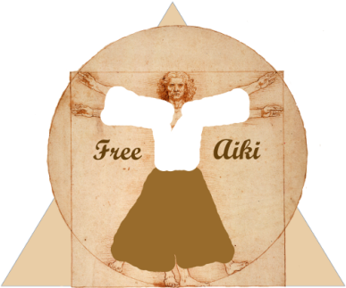**Brandon Williamscraig, Sensei, teaches on campus for Golden Bears Aikido at UC Berkeley and in the Berkeley community as Free Aiki Dojo at 1514 University Avenue (hosted by Kayla Feder Sensei and Aikido of Berkeley). Local non-profit, Association Building Community, sponsors the training and offers internships, letters of recommendation, and opportunities (paid and volunteer) to GBA officers and Peace Practices apprentices.**

**Brandon Sensei** is a 4th degree black belt who has been training since 1990 and teaching since 1996. Well known locally for cultural/political activism and co-founding Association Building Community, he is a spouse and parent and holds a Ph.D. in psychology and mythology.

***FOCUS***

**Free Aiki Dojo** is a unique training community which practices traditional aikido in order to free aiki principles to influence both personal and collective choices, in and beyond the dojo. People have practiced martial arts as long as they have existed in order to increase their readiness for stress and increase focus when things get complicated. ***If you are serious about your studies, consider becoming ready to move with good balance through whatever seems to be in your way.***

***FLOURISH***

**Golden Bears Aikido at UC Berkeley** is the extension of aiki focus and flow into the world of higher education and the liberal arts. Brandon Sensei has developed a method, called Martial Nonviolence®, and a curriculum, called Peace Practices®, that commits to practicing “conflict done well” and, in doing so, builds communities that practice peace. ***Students donate what they can to ABC, train no matter their financial capacity, and learn to ask for and render aid where and when it will do the most good.***

***Golden***

***Bears***

***Aikido***

***FINISH***

**Work with Brandon Sensei as an intern**, learn **Martial Nonviolence**® and how to model the **Peace Practices**® curriculum, and become available for training in project management, strategic collaboration and consultation, teamwork and facilitation, teaching and more. Get project management help to finish your project or dissertation. ***All who help get letters of recommendation.***

As always, follow either of our Twitter feeds for the latest changes, weekly class times, etc. at:  
<http://twitter.com/freeaiki>  
<http://twitter.com/gobearsaiki>

**Monday 12pm-1pm on campus** will feature weapons training on Faculty Glade. Bring bokken and jo if you have them. We have extras if you don't.

**Tuesday at 1514 University Ave**

CALAPALOOZA! Come table with us on Sproul Plaza between 2:30 and 5!.

Free Aiki Dojo classes are from 6:30-8:30pm at our host dojo, Aikido of Berkeley, at 1514 University Ave. From 6-6:30 you are welcome to an informal warm-up and Q&A session.  
**6:30-7:30** is a basics class w Brandon Sensei, and 7:30-8:30 is a general class with Kayla Sensei. This is an excellent evening to get to know a large cross-section of people in our training community.

**Wednesday at 1514 University Ave**

**7am -8am** is at 1514 University Ave. There is no better way to start your day!

**Thursday on campus**

**10:00 - 11:00 PM** The Late Night Thursday class is in Hearst Gym 237.

**Friday at 1514 University Ave**

**2:30pm-4:30pm** at 1514 University Ave.

**Saturday at 1514 University Ave**

**10:30am - 12pm** is at 1514 University with me this week.