Weekend Aikido Training
with Robert Frager, 7th dan

Saturday & Sunday, September 29-30, 2012

Sofia University (formerly ITP)
1069 East Meadow Circle • Palo Alto, CA

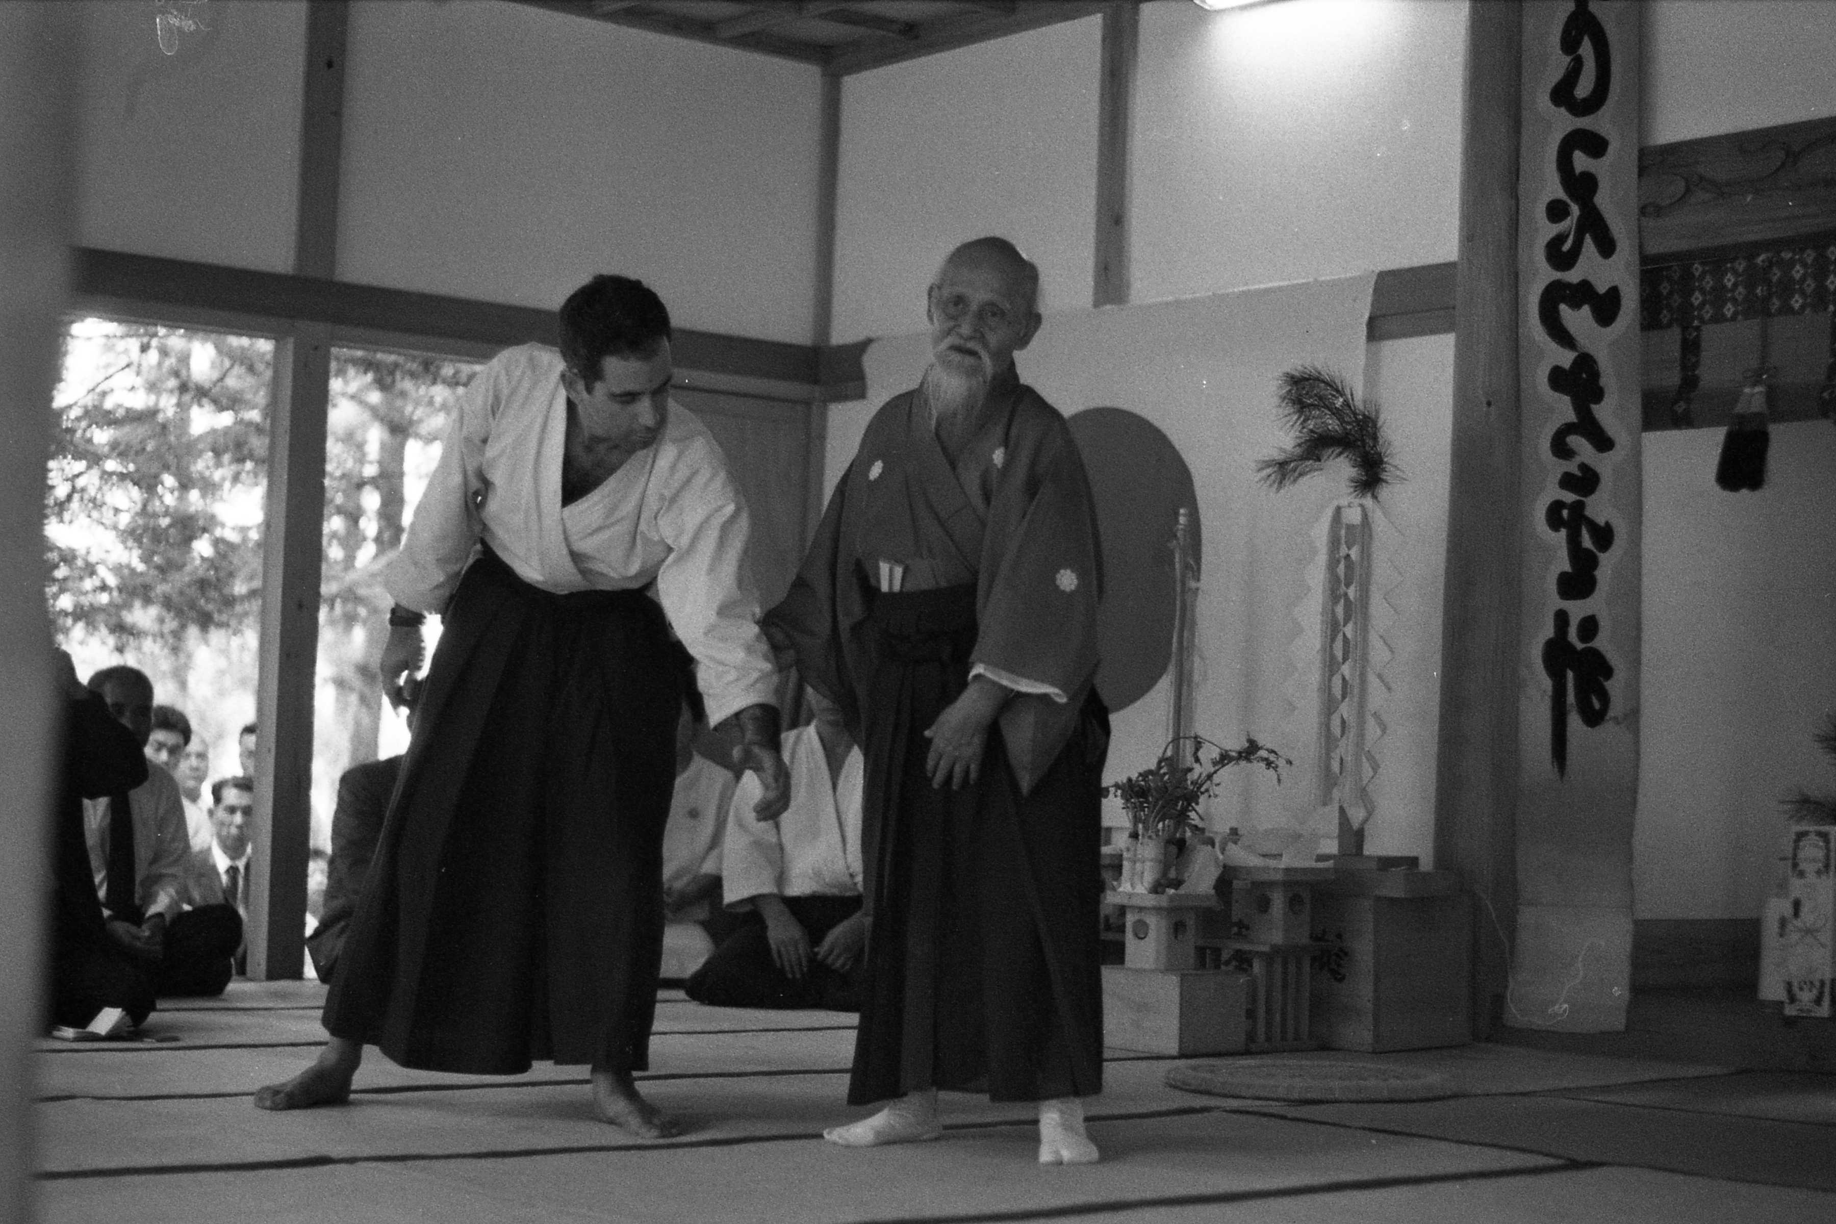

10:30-noon Training
12-1:30 pm Lunch
1:30-2:30 pm Lecture and discussion: The Floating Bridge of Heaven
2:30-3:30 pm Weapons training
4-5:00 pm Training

$75 for the weekend, $20 per class
(no one turned away for lack of money)
Half the proceeds to go to support Kato Sensei’s trips and other Association activities

To register contact: Eddie Frager 503.954.3245
info@bridgetownaikido.com

